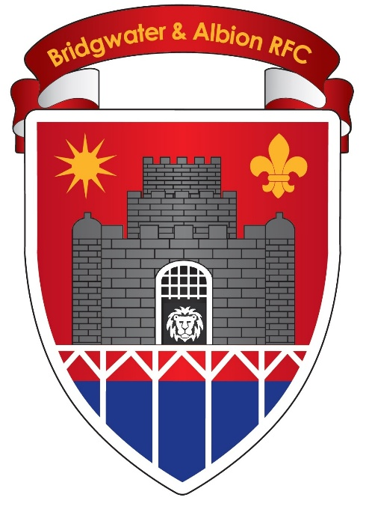

Bridgwater and Albion Rugby Football Club

Club Safeguarding Policy - Season 2026/2027

V1-2026

Policy adopted June 2026. Signed on behalf of Bridgwater & Albion RFC:

Stephen Smith Chris Moore
Club Chairman Safeguarding Officer
Bridgwater & Albion RFC Bridgwater & Albion RFC

Safeguarding Policy

- Bridgwater and Albion RFC acknowledges its responsibility to safeguard the welfare of all children involved in [club name] from harm.

- Bridgwater and Albion RFC confirms that it adheres to the Rugby Football Union’s Safeguarding Policy and the procedures, practices and guidelines and endorse and adopt the Policy Statement contained in that document and any successor policy.

- A child is anyone under the age of 18 engaged in any rugby union activity. However, where a 17 year old male player is playing in the adult game it is essential that every reasonable precaution is taken to ensure his safety and wellbeing are protected.

- The Key Principles of the RFU Safeguarding Policy are that:

- The welfare of the child is, and must always be, paramount to any other considerations.

- All participants regardless of age, gender, ability or disability, race, faith, culture, size, shape, language or sexual identity have the right to protection from abuse or harm.

- All allegations or suspicions of abuse, neglect, harm and poor practice will be taken seriously and responded to swiftly, fairly and appropriately.

- Working in partnership with other organisations, statutory agencies, parents, carers, children and young people is essential for the welfare of children.
- Children have a right to expect support, and personal and social development delivered by an appropriately recruited, vetted and managed in relation to their participation in rugby union, whether they are playing, volunteering or officiating in the community or professional areas of the sport.

- Bridgwater and Albion RFC recognises that all children have the right to participate in sport in a safe, positive and enjoyable environment whilst at the same time being protected from abuse, neglect, harm and poor practice. Bridgwater and Albion RFC recognises that this is the responsibility of everyone involved, in whatever capacity, at the club.

- Bridgwater and Albion RFC will implement and comply with the RFU Code of Conduct and the Codes of Conduct for Coaches, Spectators and Officials as appropriate.

- The Club Safeguarding Officer is :

Chris Moore
chris.moore7985@outlook.com
07885574908

If you witness or are aware of an incident where the welfare of a child has been put at risk you must, in the first instance, inform the Club Safeguarding Officer. They will then inform the CB Safeguarding
Manager and the RFU Safeguarding Team. If an incident involves the Club Safeguarding Officer you should inform the Club Chairman or the Youth Chairman, and either the CB Safeguarding Manager or the RFU Safeguarding Team. If a child is at risk of harm and contact cannot be made with the RFU, please contact the police using 999 or out-of-hours children's social care. You can also call the NSPCC on their contact line using the details below.

Club Chairman

Stephen Smith - 07387260713

Youth Co-Chairman

Joe Stradling - 07967124797
Ian Stone - 07881238543

RFU Safeguarding Team

safeguarding@rfu.com /
0208 831 6655 (24hr automated service)

NSPCC
0808 800 5000,10:00 AM - 16:00 PM Monday to Friday

Children’s Social Care – Somerset

0300 123 2224

- All members of Bridgwater and Albion RFC who work with children in Regulated Activity must undertake an RFU Disclosure and Barring Service (DBS) check in accordance with RFU Regulation 21.

- Bridgwater and Albion RFC will ensure that all its members, whether they are coaches, parents, players or officials will comply with the Best Practice Guidance as issued by the RFU. In summary, the following are NOT acceptable and will be treated seriously by the club and may result in disciplinary action being taken by the club, the CB or the RFU:

  - Working alone with a child.
  - Consuming alcohol whilst responsible for children.
  - Providing alcohol to children or allowing its supply.
  - Smoking in the presence of children.
  - Humiliating children.
  - Inappropriate or unnecessary physical contact with a child.
  - Participating in, or allowing, contact or physical games with children.
  - Having an intimate or sexual relationship with any child developed as a result of being in a ‘position of trust.’
  - Making sexually explicit comments or sharing sexually explicit material.

- Bridgwater and Albion RFC manages the changing facilities and arranges for them to be supervised by two DBS checked adults of the appropriate gender for the players using the facilities. Bridgwater and Albion RFC ensures that all its coaches, parents, officials and spectators are aware that adults must not change at the same time, using the same facilities as children.

- Bridgwater and Albion RFC will ensure that its coaches and team managers will receive the support and training considered appropriate to their position and role.

- Any events held on Bridgwater and Albion RFC premises must comply with this Policy and if appropriate a Safeguarding Plan should be discussed and circulated to those affected. Any tours, overseas or domestic, undertaken by Bridgwater and Albion RFC must comply with the relevant RFU Regulations and Guidance relating to tours.

More information can be found at

https://www.englandrugby.com/run/safeguarding

